SN | Project Name | Technical parameters (performance and configuration)
Item Name |  | Integral Dental Unit
Model |  | YD-A3（26）
First. Working Conditions, Standards, and Structure
1、 | Product operating conditions | 1. Ambient temperature range: 5℃～40℃  2. Relative humidity: ≤80% RH  3. Atmospheric pressure range: 86kPa～106kPa  4. Power supply: Including a.c. 220V±22V, 50/60Hz±1Hz (The dental chair and treatment unit all operate on safe low voltage of AC 24V and DC 36V)  5. Water pressure range: 200kPa～400kPa  6. Air source pressure: Maximum value not less than 500kPa, not greater than 700kPa, flow rate not less than 50L/min  7. The ground where the treatment unit is installed should be level, and the inclination of the treatment unit body after installation should not exceed 0.1°.
2、 | Equipment standards | 1. Class I product for protection against electric shock, protection level: Type B  2. Treatment unit standard: Q/XY11-2002  3. Dental chair standard: Q/XY21-2002  4. Treatment unit electrical standard: IEC60601-1/2  5. Water and air pipelines are pressure-resistant up to 10 kg; German-imported water and air pipelines are made of environmentally friendly, odorless, and non-toxic materials.  6. Metal parts structure uses capacitive processing technology.  7. Exterior metal parts use baking paint process + cast aluminum manufacturing technology.  8. Plastic parts use ABS environmentally friendly material injection molding process.  9. Water and air lines are equipped with filters to remove impurities; water and air flow can be independently adjusted via regulating valves.  10. Components include: chair (system control, motor drive), main unit (treatment panel, solenoid valve, water heater), instrument tray (viewing light, control panel), lamp (oral light, lamp arm).
3、 | Structural form | Fully computerized system control function
Second、Components of the treatment device
1、 | Main and assistant systems | - 1.7-inch LCD screen computer control operating system;  - The LCD screen computer control panel features function keys for memory, reset, dental chair lifting and tilting, mouthwash, heated water, and bowl rinsing.
2、 | Concealed enclosure | 1. No visible cabinet, hidden design  2. Provides ample space for six-handed operation, making treatment procedures more convenient  3. The product can be used with both left and right hands  4. Strong and weak suction uses a filter that is easy to disassemble and clean  5. Uses a 600 ML external purified water bottle, easy to remove and refill  6. 2000° high-temperature fired ceramic spittoon; at a water pressure of 0.2 MPa, the water can reach the entire circumference of the spittoon bottom. Smooth drainage, with a drainage speed of no less than 4L/min. The ceramic spittoon has smooth inner and outer surfaces, is easy to disinfect, and is detachable and rotatable by 180°.  7. Automatic heating and constant temperature water supply device, mouthwash water supply device, adjustable water volume, water temperature approximately 40-60°, adjustable water output  8. Purified water supply system, allowing flexible selection of tap water or purified water for the handpiece.  9. Luxurious F02 six-in-one multi-functional foot pedal system controls chair position adjustment, spittoon flushing, water and air conversion, and other functions.  10. Equipped with stainless steel foot pedal tubing, durable and pressure-resistant.
3、 | Assistant part | 1. The assistant's support bracket is made of aluminum and includes strong and weak suction functions; strong suction is controlled by air, and weak suction is controlled by water.  2. The strong and weak suction saliva ejectors operate on a negative pressure principle, with a vacuum degree of no less than 27kPa and a water suction rate of no less than 1L/min. Both strong and weak suction systems have a cleaning filter screen device with sediment filtration function.  3. The strong and weak suction tubing uses environmentally friendly, non-toxic German-imported silicone spiral tubing.  4. The three-way syringe can provide water, air, and mist, with warm water control function.  5. A secondary control system is used; the system can control chair position adjustment, sputum rinsing, and water supply functions.  The assistant's position bracket features a double-joint design, allowing for a total rotation of ≥180°, to accommodate left-handed operation.
4、 | LED oral lamp | 1. Luxury G8 LED 8-hole dual-color cool light source + luxury square lamp arm assembly, all lamp beads use imported Osram light sources.  2. Features freely adjustable light source and color temperature; strong light intensity ≥50000 lux, weak light intensity ≥6000 lux.  3. Inductive and manual dual control system.  4. Anti-curing technology light source design.  5. Lamp handle with removable and sterilizable silicone cover.  The dental lamp bracket adopts a downward-facing design and can rotate 300° to accommodate both left-handed and right-handed operation.
5、 | Dentist table | 1. Built-in 24V low-voltage 7-inch X-ray viewer, controlled via system buttons.  2. Pneumatic locking system for the instrument tray allows for up, down, left, and right movement for convenient operation.  3. Equipped with a three-way syringe, low-speed handpiece tubing, and high-speed handpiece tubing.  4. Independent air pressure adjustment for the handpiece tubing; air pressure displayed on a pressure gauge, with water adjustment function.  5. Silicone tray above the instrument tray, equipped with a sterilizable silicone mat and a 304 stainless steel tray, and can rotate 180°.  6. Brand new integrated instrument control panel.  7. 304 stainless steel handle bracket to prevent cross-infection.  8. 7-inch LCD control system; the LCD screen is medical-grade, and the key main system control uses imported chips.  The instrument arm bracket features a downward-facing design and can rotate 300° to accommodate both left and right-handed operation.
Third、Dental chair system control
1、 | Structure | The overall structure utilizes a large amount of cast aluminum, including the backrest support, armrest base, seat cushion support, base plate, and base of the storage compartment; it is treated with capacitive coating/baking paint before use, effectively preventing rust.
2、 | Control system | The dental chair is controlled by a main, auxiliary, and foot pedal control system, which controls all its operational functions.
3、 | Power system | The power system uses an imported DC silent motor, ensuring smooth operation, low noise, and maintenance-free performance. Minimum chair height: 380mm, maximum chair height: 700mm, load capacity ≤ 180Kg.
4、 | Performance requirements | - 1. The entire dental chair and treatment unit system uses safe low voltage of AC 24V and DC 36V.  - 2. The dental treatment unit casing is made of ABS thermoformed material, which is non-toxic, odorless, durable, and easy to clean.  - 3. The dental chair backrest and seat cushion are made of environmentally friendly wood material, with skin-friendly leather cushions and lumbar and headrests for enhanced comfort; the overall design is wide and comfortable, conforming to ergonomic principles.  - 4. The electric dental chair has an emergency anti-shock chair position setting function with a negative 2° tilt and a height of 85cm.  - 5. The dental chair has a reset program chair position function.  - 6. The dental chair headrest is freely adjustable to meet the needs of different treatment angles.  - 7. The dental chair backrest height is adjustable by ≥15°, with an adjustment range of no less than 10CM, to meet the needs of patients of different heights.  - 8. Single armrest design, with the left armrest fixed.  - 9. The water and air pipelines use German BASF materials, ensuring a service life of more than 10 years.
IV. Nurse's chair (for distance learning) + Deluxe doctor's chair 019
1 | Architecture | The dentist chair features adjustable height and a lockable backrest position.
2 | Lifting/lowering | Minimum chair height: 400mm, travel range: 80mm
3 | Backrest | Large backrest + injected foam backrest
Fifth、Item photo
Diagram | 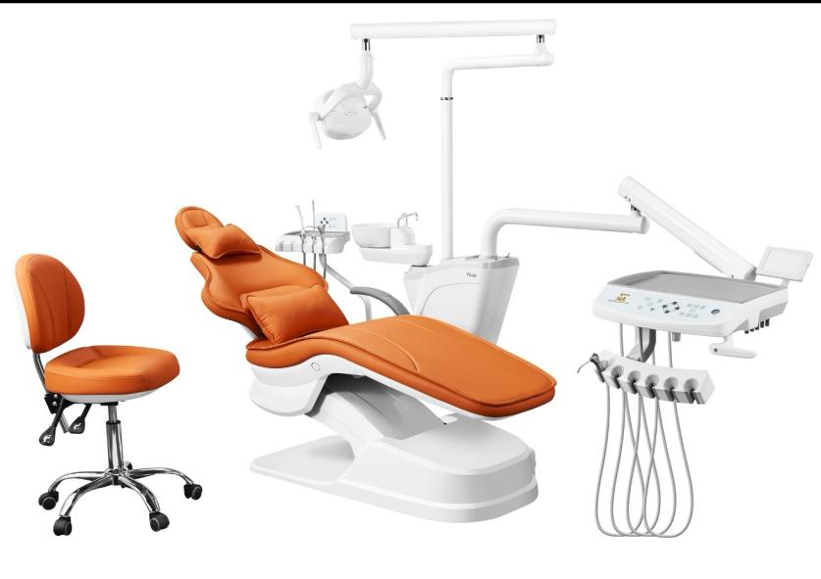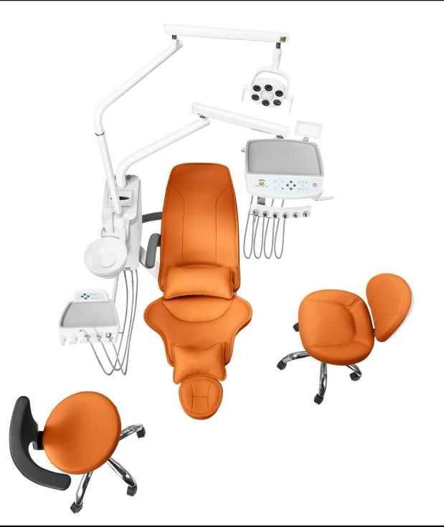
Sixth、Factory configuration
NO | QTY | name
1 | 1 set | Brand New Third Generation Linkage Compensation Electric Dental Chair
2 | 2 pieces | Imported DC Silent Motor
3 | 2 pieces | Imported Solenoid Valve
4 | 2 pieces | Three-way Syringe (Cold/Hot)
5 | 1 set | 4.3-inch LCD Sub-control System
6 | 1 set | Saliva Suction System
7 | 1 set | Purified Water System
8 | 1 piece | LED X-ray Viewer
9 | 1 set | Ultra-fine Skin-friendly Leather Cushion + Lumbar and Headrest Pillows
10 | 1 sheet | Luxury Doctor's Chair + Nurse's Chair
11 | 1 set | Sputum Flushing and Water Supply System
12 | 1 piece | Luxury G8 LED Oral Light
13 | 1 sheet | Replaceable and Sterilizable Instrument Tray Silicone Anti-fouling Cover
14 | 1 set | F02 Stainless Steel Six-in-One Multifunctional Foot Control
15 | 1 set | Luxury Cast Aluminum Single-hand Control Multifunctional Headrest Bracket
16 | 1 set | Removable and Sterilizable Ceramic Spittoon
17 | 1 set | Linkage Compensation Chair Position Control Structure
18 | 1 set | German Imported Water and Air Pipelines
19 | 1 piece | Stainless Steel Foot Pedal Tube
20 | 1 set | Integrated 6-position Hanger Assembly
以下为种植款选购配置
1 | 1 set | Luxury Cast Aluminum Removable Backrest Support Base
2 | 1 set | The following are optional configurations for the implant model:
3 | 1 piece | Stainless Steel Auxiliary Tray Assembly (with air-lock controlled lifting)
Seventh、Parameter
NO | QTY | name
1 | 1 | Imported NSK high and low-speed handpieces
2 | 1 | Domestic high and low-speed handpieces
3 | 1 | Woodpecker built-in N2 LED scaler
4 | 1 | Woodpecker built-in G/Q type light curing unit
5 | 1 | Endoscope system
6 | 1 | Silent oil-free air compressor
7 | 1 | Negative pressure suction system
8 | 1 | Overhead instrument tray
9 | 1 | Microfiber leather and genuine leather cushions
10 | 1 | Height-adjustable trolley
11 | 1 | Stainless steel tray assembly
12 | 1 | Shadowless lamp
VIII. Parameters
1 | Current and voltage | 220V±10V 50Hz/60Hz
2 | DC motor | 24V
3 | Air source pressure | ＞0.55MPa
4 | Water source pressure | 0.2MPa-0.4MPa
5 | Oral lamp illuminance | ≥12000Lux
6 | X-ray viewer brightness | ≥2000FL
7 | Ambient temperature | 5℃～40℃
8 | Relative humidity | ≤80％RH
9 | Atmospheric pressure | 86kPa～106kPa
10 | Machine body tilt | ≤0.1°

